1)

Component 1: ListofPlayers

import React from 'react';

const ListofPlayers = () => {

const players = [

{ name: 'Virat', score: 95 },

{ name: 'Rohit', score: 88 },

{ name: 'Dhoni', score: 67 },

{ name: 'Kohli', score: 99 },

{ name: 'Jadeja', score: 45 },

{ name: 'Bumrah', score: 76 },

{ name: 'Shami', score: 62 },

{ name: 'Gill', score: 71 },

{ name: 'Karthik', score: 58 },

{ name: 'Ashwin', score: 73 },

{ name: 'Pant', score: 69 }

];

const below70 = players.filter(player => player.score < 70);

return (

<div>

<h2>All Players</h2>

<ul>

{players.map((player, index) => (

<li key={index}>{player.name} - {player.score}</li>

))}

</ul>

<h3>Players with score below 70</h3>

<ul>

{below70.map((player, index) => (

<li key={index}>{player.name} - {player.score}</li>

))}

</ul>

</div>

);

};

export default ListofPlayers;

Component 2: IndianPlayers

import React from 'react';

const IndianPlayers = () => {

const team = ['Player1', 'Player2', 'Player3', 'Player4', 'Player5', 'Player6'];

const oddTeam = team.filter((_, index) => index % 2 !== 0);

const evenTeam = team.filter((_, index) => index % 2 === 0);

const T20players = ['Hardik', 'Surya', 'Ishan'];

const RanjiTrophy = ['Pujara', 'Rahane', 'Shaw'];

const allPlayers = [...T20players, ...RanjiTrophy]; // Using ES6 spread operator

return (

<div>

<h2>Odd Team Players</h2>

<ul>

{oddTeam.map((player, i) => <li key={i}>{player}</li>)}

</ul>

<h2>Even Team Players</h2>

<ul>

{evenTeam.map((player, i) => <li key={i}>{player}</li>)}

</ul>

<h2>Merged Players (T20 + Ranji)</h2>

<ul>

{allPlayers.map((player, i) => <li key={i}>{player}</li>)}

</ul>

</div>

);

};export default IndianPlayers;

src/App.js

import React from 'react';

import ListofPlayers from './ListofPlayers';

import IndianPlayers from './IndianPlayers';

function App() {

const flag = true; // Toggle between true/false to see different components

return (

<div className="App">

<h1>Cricket App</h1>

{flag ? <ListofPlayers /> : <IndianPlayers />}

</div>

);

}

export default App;

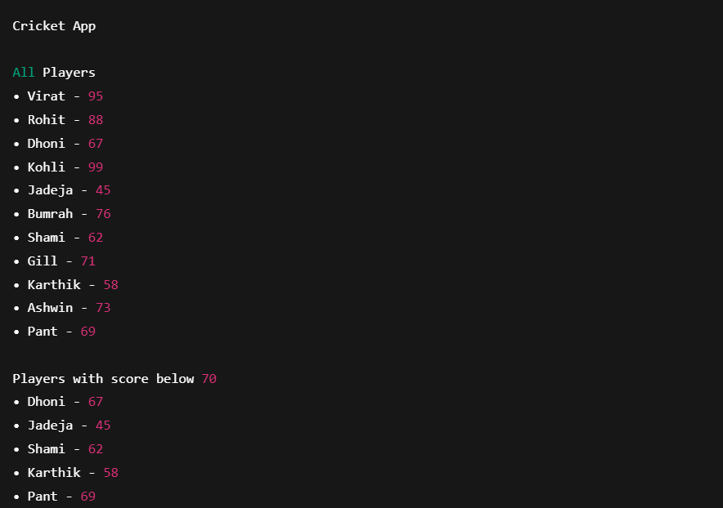

2)

App.js

import React from 'react';

function App() {

// Office data object

const office = {

name: "Regus Space",

rent: 55000,

address: "Downtown Avenue, Bengaluru",

imageUrl: "https://via.placeholder.com/300x200?text=Office+Space"

};

// Array of multiple office items

const officeList = [

{

name: "WeWork",

rent: 45000,

address: "MG Road, Bengaluru"

},

{

name: "Innov8",

rent: 65000,

address: "Koramangala, Bengaluru"

},

{

name: "91Springboard",

rent: 60000,

address: "HSR Layout, Bengaluru"

}

];

// JSX rendering

return (

<div style={{ padding: '20px', fontFamily: 'Arial' }}>

{/* JSX Element for Heading */}

<h1 style={{ textAlign: 'center' }}>Office Space Rental App</h1>

{/* JSX Attribute for Image */}

<img

src={office.imageUrl}

alt="Office Space"

style={{ display: 'block', margin: '0 auto 20px', width: '300px', height: '200px' }}

/>

{/* Object Data Rendering */}

<div style={{ marginBottom: '30px' }}>

<h2>{office.name}</h2>

<p><strong>Address:</strong> {office.address}</p>

<p>

<strong>Rent:</strong>

<span style={{ color: office.rent < 60000 ? 'red' : 'green' }}>

{' ₹' + office.rent}

</span>

</p>

</div>

{/* Rendering List of Offices with Conditional Styling */}

<h2>Available Office Spaces</h2>

{officeList.map((item, index) => (

<div

key={index}

style={{

border: '1px solid #ccc',

padding: '15px',

marginBottom: '10px',

borderRadius: '8px'

}}

>

<h3>{item.name}</h3>

<p><strong>Address:</strong> {item.address}</p>

<p>

<strong>Rent:</strong>

<span style={{ color: item.rent < 60000 ? 'red' : 'green' }}>

{' ₹' + item.rent}

</span>

</p>

</div>

))}

</div>

);

}

export default App;

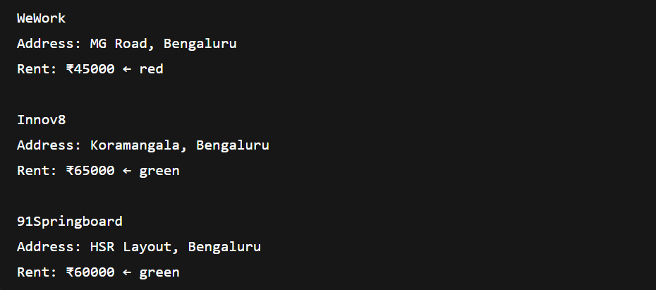

3)

src/CurrencyConvertor.js

import React, { useState } from 'react';

const CurrencyConvertor = () => {

const [rupees, setRupees] = useState('');

const [euro, setEuro] = useState(null);

const conversionRate = 0.011; // Assume ₹1 = €0.011

const handleSubmit = (event) => {

event.preventDefault(); // Synthetic Event

const converted = rupees * conversionRate;

setEuro(converted.toFixed(2));

};

return (

<div>

<h2>Currency Convertor (INR to EURO)</h2>

<form onSubmit={handleSubmit}>

<input

type="number"

value={rupees}

onChange={(e) => setRupees(e.target.value)}

placeholder="Enter amount in INR"

/>

<button type="submit">Convert</button>

</form>

{euro !== null && <p>€ {euro}</p>}

</div>

);

};

export default CurrencyConvertor;

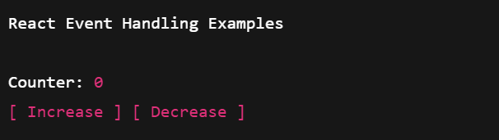

4)

App.js

import React, { useState } from 'react';

function GuestPage() {

return (

<div>

<h2>Welcome Guest</h2>

<p>You can view flight details below:</p>

<ul>

<li>Flight 1: Bengaluru → Delhi</li>

<li>Flight 2: Mumbai → Chennai</li>

<li>Flight 3: Hyderabad → Kolkata</li>

</ul>

</div>

);

}

function UserPage({ onLogout }) {

return (

<div>

<h2>Welcome User</h2>

<p>You are logged in. You can book tickets now.</p>

<button onClick={onLogout}>Logout</button>

<div style={{ marginTop: '20px' }}>

<h3>Book a Flight</h3>

<p>Select your flight and proceed with booking.</p>

<ul>

<li>Flight 1: Book</li>

<li>Flight 2: Book</li>

<li>Flight 3: Book</li>

</ul>

</div>

</div>

);

}

function App() {

const [isLoggedIn, setIsLoggedIn] = useState(false);

const handleLogin = () => setIsLoggedIn(true);

const handleLogout = () => setIsLoggedIn(false);

let page;

if (isLoggedIn) {

page = <UserPage onLogout={handleLogout} />;

} else {

page = (

<div>

<GuestPage />

<button onClick={handleLogin}>Login</button>

</div>

);

}

return (

<div style={{ padding: '20px', fontFamily: 'Arial' }}>

<h1>Ticket Booking App</h1>

{page}

</div>

);

}

export default App;

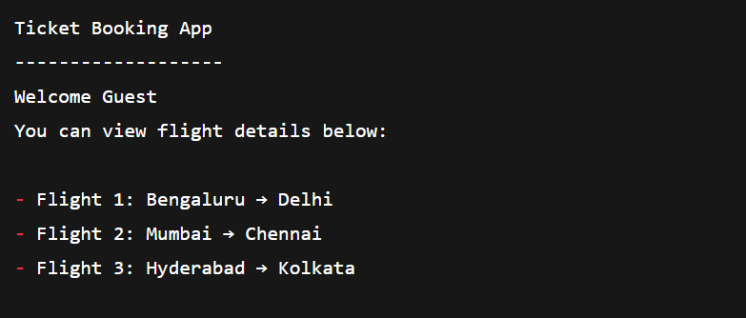

4)

BookDetails.js

import React from 'react';

const books = [

{ id: 1, title: "Atomic Habits", author: "James Clear" },

{ id: 2, title: "Deep Work", author: "Cal Newport" },

{ id: 3, title: "Clean Code", author: "Robert C. Martin" }

];

const BookDetails = () => {

return (

<div>

<h2>Book Details</h2>

<ul>

{books.map((book) => (

<li key={book.id}>

📘 <strong>{book.title}</strong> by {book.author}

</li>

))}

</ul>

</div>

);

};

export default BookDetails;

BlogDetails.js

import React from 'react';

const blogs = [

{ id: 101, title: "Why Learn React?", date: "2025-01-10" },

{ id: 102, title: "JavaScript Tips", date: "2025-01-15" }

];

const BlogDetails = () => {

return (

<div>

<h2>Blog Posts</h2>

{blogs.map(blog => (

<div key={blog.id}>

📝 <strong>{blog.title}</strong> - {blog.date}

</div>

))}

</div>

);

};

export default BlogDetails;

CourseDetails.js

import React from 'react';

const courses = [

{ id: 'C1', name: "React Basics", duration: "4 weeks" },

{ id: 'C2', name: "Advanced React", duration: "6 weeks" }

];

const CourseDetails = () => {

return (

<div>

<h2>Course List</h2>

<ul>

{courses.map(course => (

<li key={course.id}>

🎓 {course.name} - {course.duration}

</li>

))}

</ul>

</div>

);

};

export default CourseDetails;

import React, { useState } from 'react';

import BookDetails from './BookDetails';

import BlogDetails from './BlogDetails';

import CourseDetails from './CourseDetails';

function App() {

const [view, setView] = useState('book'); // 'book', 'blog', 'course'

// Method 1: If-Else

let content;

if (view === 'book') {

content = <BookDetails />;

} else if (view === 'blog') {

content = <BlogDetails />;

} else {

content = <CourseDetails />;

}

return (

<div style={{ padding: '20px', fontFamily: 'Arial' }}>

<h1>Blogger App</h1>

<div>

<button onClick={() => setView('book')}>Show Books</button>

<button onClick={() => setView('blog')}>Show Blogs</button>

<button onClick={() => setView('course')}>Show Courses</button>

</div>

<hr />

{/* Method 2: Element Variable */}

{content}

{/* Method 3: Ternary Operator (Inline) */}

{/* {view === 'book' ? <BookDetails /> : view === 'blog' ? <BlogDetails /> : <CourseDetails />} */}

{/* Method 4: Logical && Operator */}

{/* {view === 'book' && <BookDetails />}

{view === 'blog' && <BlogDetails />}

{view === 'course' && <CourseDetails />} */}

</div>

);

}

export default App;

